# Get Team Names with CTEs (Step 2)

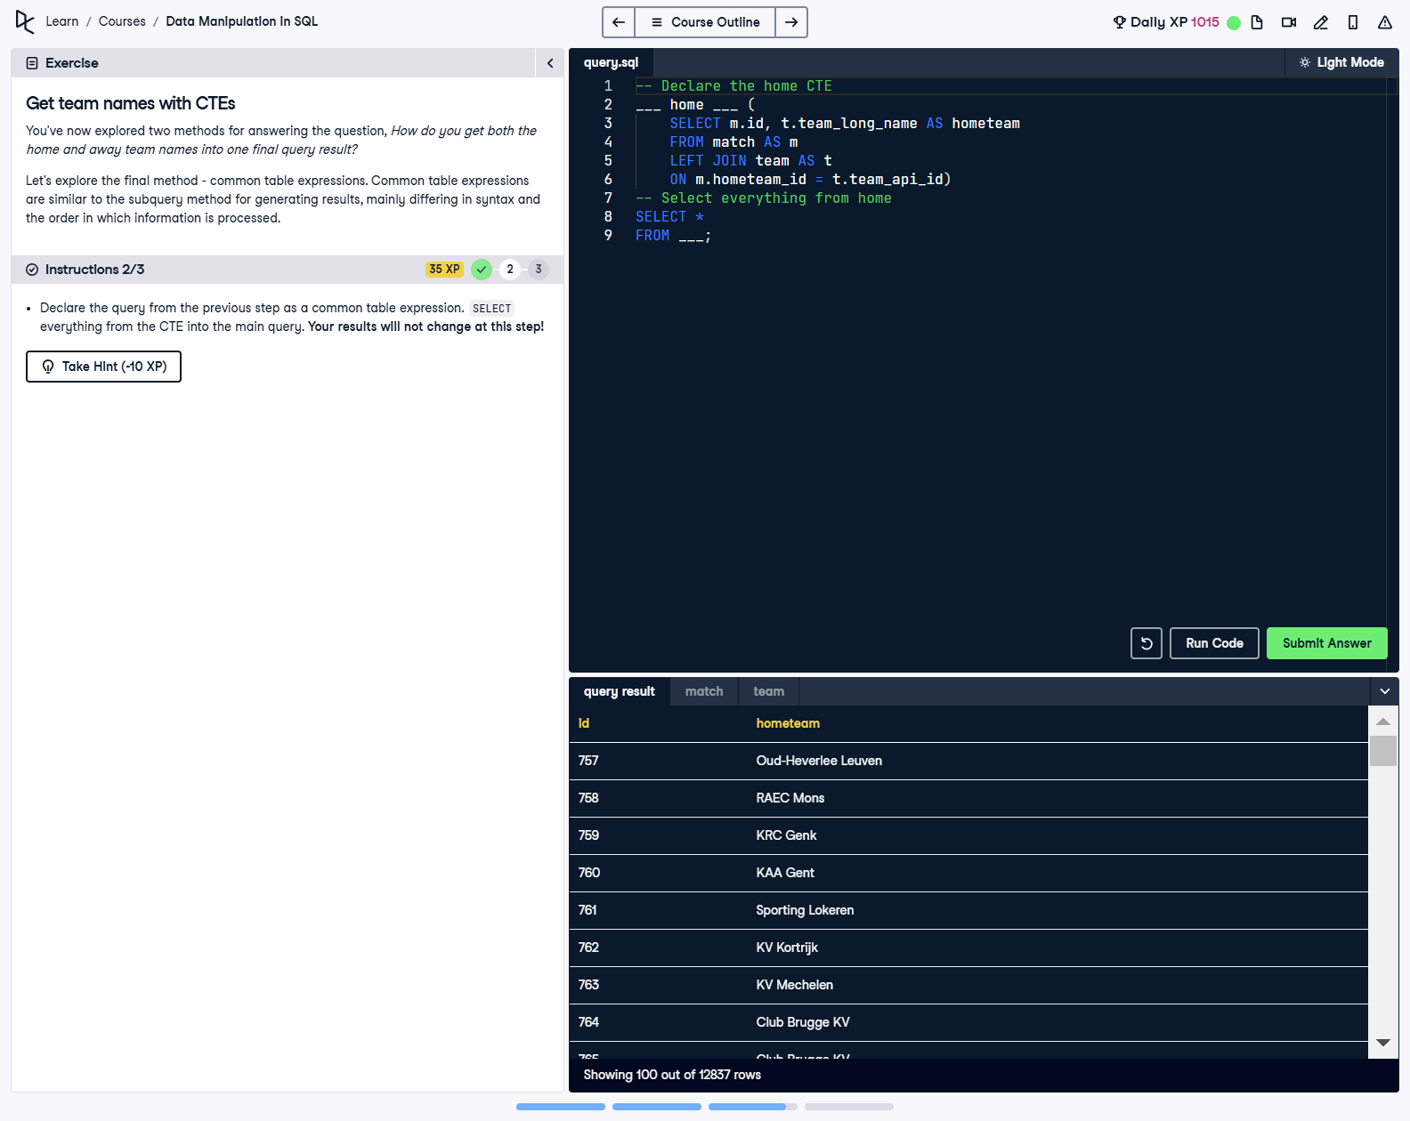

## Question

1. Declare the query from the previous step as a common table expression.  
  
2. SELECT everything from the CTE into the main query. Your results will not change at this step.

## Corrected Solution

-- Declare the home CTE  
WITH home AS (  
 SELECT   
 m.id,   
 t.team_long_name AS hometeam  
 FROM match AS m  
 LEFT JOIN team AS t  
 ON m.hometeam_id = t.team_api_id  
)  
-- Select everything from home  
SELECT *  
FROM home;

## Explanation

This query defines a Common Table Expression (CTE) named 'home' that retrieves match IDs and home team names by performing a LEFT JOIN between the match and team tables. The main query selects all columns from the CTE, effectively displaying the results of the CTE. This approach organizes the query into reusable and modular components.